Foundational Elements of Project Management

Table of Contents

Projects 2

Project Initiation 4

Project Challenges 6

Project, Program, Portfolio and Operations Management 6

Operations 10

Organizational Project Management 10

Project Lifecycle Management 11

Project Management Business Documents 16

Business Cases 16

Benefit Management Plan 17

## Projects

A **project** is a temporary endeavor undertaken to create a unique product, service or result (outcomes of a research project). It can also be a combination of these. These outcomes are called the **deliverables** of the project. The deliverables can have long term effects beyond the project itself. The deliverables can have **repetitive elements**, such as the building blocks of a building, but the deliverable itself is still unique.

The fact that a project is **temporary** means there is a defined start and end to the project. The project ends when the objectives have been met, it is decided that they cannot be met or when all funds have been exhausted. Note that the project being temporary does not necessarily mean that the time spent on it is a short one.

Projects **drive change** in organizations. Successful completion of the project increases the **business value** moving it from one state to another. The business value increases by an amount equal to the **net quantifiable deliverables** achieved from the business endeavor.

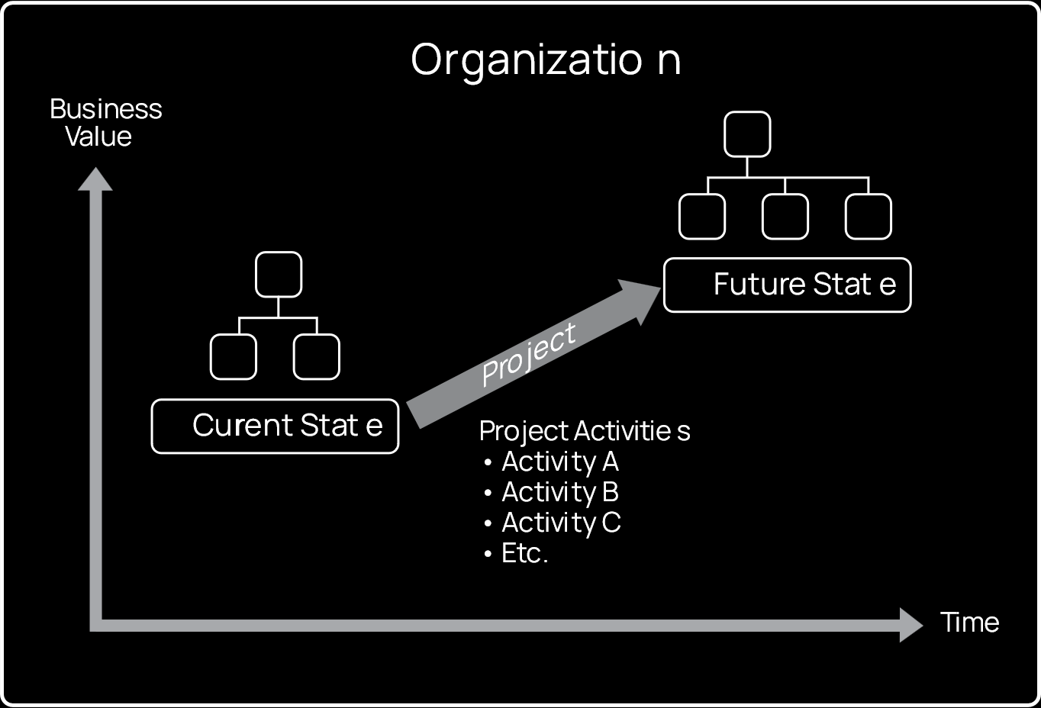

The change in state does not necessarily happen at once. The project may be comprised of **several activities**, each of which move the business closer towards the future state.

Projects enable **business value creation**. The business value could be **tangible** or **intangible** and is achieved in exchange of time, money, etc. Possible tangible elements of business value include assets, shares, fixtures, etc., while possible intangible elements include goodwill, brand recognition, trademarks, reputation, etc.

## Project Initiation

Projects are usually initiated due to a combination of the following four factors:

1. A need to meet regulatory legal or social requirements.
2. To satisfy the requests or needs of stakeholders.
3. To create, improve or fix products or services.
4. To implement or change business or technical strategies.

The following table shows examples of projects that were created due to the above factors:

|  |  |  |  |  |  |
| --- | --- | --- | --- | --- | --- |
| **Specific Factor** | **Example** | **Meet Regulatory, Legal, or Social Requirements** | **Satisfy Stakeholders Requests or Needs** | **Create, Improve, of Fix Products, Processes, or Services** | **Implement or Change Business or Technological Strategies** |
| **New technology** | An electronics firm authorizes a new project to develop a faster, cheaper, and smaller laptop based on advances in computer memory and electronics technology |  |  | **✓** | **✓** |
| **Competitive forces** | Lower pricing on products by a competitor result in the need to lower production costs to remain competitive |  |  |  | **✓** |
| **Material issues** | A municipal bridge developed cracks in some support members resulting in a project to fix the problems | **✓** |  | **✓** |  |
| **Political changes** | A newly elected official instigating project funding changes to a current project |  |  |  | **✓** |
| **Market demand** | A car company authorizes a project to build more fuel-efficient cars in response to gasoline shortages |  | **✓** | **✓** | **✓** |
| **Economic changes** | An economic downturn results in a change in the priorities for a current project |  |  |  | **✓** |
| **Customer request** | An electric utility authorizes a project to build a substation to serve a new industrial park |  | **✓** | **✓** |  |
| **Stakeholder demands** | A stakeholder requires that a new output be produced by the organization |  | **✓** |  |  |
| **Legal requirement** | A chemical manufacturer authorizes a project to establish guidelines for the proper handling of a new toxic material | **✓** |  |  |  |
| **Business process improvements** | An organization implements a project resulting from a Lean Six Sigma value stream mapping exercise |  |  | **✓** |  |
| **Strategic opportunity or business need** | A training company authorizes a project to create a new course to increase its revenues |  |  | **✓** | **✓** |
| **Social need** | A nongovernmental organization in a developing country authorizes a project to provide potable water systems, latrines, and sanitation education to communities suffering from high rates of infectious diseases |  | **✓** |  |  |
| **Environmental considerations** | A public company authorizes a project to create a new service for electric car sharing to reduce pollution |  |  | **✓** | **✓** |

## Project Challenges

Common challenges for projects include:

1. Short timelines
2. Tight budgets
3. Scarcity of resources
4. Rapid changes in technology

It is the job of **managers** to manage these challenges. Being able to meet these challenges is an indication of good management, which can lead to improved reputation.

## Project, Program, Portfolio and Operations Management

We have already studied what projects are, but that is just one part of how an organization operates. We also have programs and portfolios.

A **program** is a collection of related projects which, if we manage them together, gives us more benefits than if we managed each project separately. For example, a satellite system is a program because it consists of lots of projects which should ideally be managed together.

A **portfolio** is a collection of projects and programs that are managed as a group in order to achieve the strategic goals of the organizations. For example, a single organization could have projects and programs related to power, oil and gas. There needs to be coordination between the three in order for them to collective work towards the organizational goals.

The diagram below shows the relationship between projects, programs and portfolios:



Notice that all of the projects are working off of **shared resources** and have the same stakeholders. On the flip side we have things like risk management, managing funds, etc., i.e., critical aspects of the organization which affect all projects and programs. These are handled at the portfolio level.

Although they are related, projects, programs and portfolios have several differences. These are outlined in the table below:

|  |  |  |  |
| --- | --- | --- | --- |
| **Organizational Project Management** | | | |
|  | Projects | Programs | **Portfolios** |
| **Definition** | A project is a temporary endeavor undertaken to create a unique product, service, or result. | A program is a group of related projects, subsidiary programs, and program activities that are managed in a coordinated manner to obtain benefits not available from managing them individually. | A portfolio is a collection of projects, programs, subsidiary portfolios, and operations managed as a group to achieve strategic objectives. |
| **Scope** | Projects have defined objectives. Scope is progressively elaborated throughout the project life cycle. | Programs have a scope that encompasses the scopes of its program components. Programs produce benefits to an organization by ensuring that the outputs and outcomes of program components are delivered in a coordinated and complementary manner. | Portfolios have an organizational scope that changes with the strategic objectives of the organization. |
| **Change** | Project managers expect change and implement processes to keep change managed and controlled. | Programs are managed in a manner that accepts and adapts to change as necessary to optimize the delivery of benefits as the program’s components deliver outcomes and/or outputs. | Portfolio managers continuously monitor changes in the broader internal and external environments. |
| **Planning** | Project managers progressively elaborate high-level information into detailed plans throughout the project life cycle. | Programs are managed using high-level plans that track the interdependencies and progress of program components. Program plans are also used to guide planning at the component level. | Portfolio managers create and maintain necessary processes and communication relative to the aggregate portfolio. |
| **Management** | Project managers manage the project team to meet the project objectives. | Programs are managed by program managers who ensure that program benefits are delivered as expected, by coordinating the activities of a program’s components. | Portfolio managers may manage or coordinate portfolio management staff, or program and project staff that may have reporting responsibilities into the aggregate portfolio. |
| **Monitoring** | Project managers monitor and control the work of producing the products, services, or results that the project was undertaken to produce. | Program managers monitor the progress of program components to ensure the overall goals, schedules, budget, and benefits of the program will be met. | Portfolio managers monitor strategic changes and aggregate resource allocation, performance results, and risk of the portfolio. |
| **Success** | Success is measured by product and project quality, timeliness, budget compliance, and degree of customer satisfaction. | A program’s success is measured by the program’s ability to deliver its intended benefits to an organization, and by the program’s efficiency and effectiveness in delivering those benefits. | Success is measured in terms of the aggregate investment performance and benefit realization of the portfolio. |

### Operations

One aspect of the organization that was skipped over is **operations**. These are similar to projects but fall outside their scope, since they are somewhat like **ongoing projects**. Things like accounting and the production of existing products fall into the operations category since they are projects which never end. They simply take some input and give some output.

## Organizational Project Management

Based on the concept of projects, programs and portfolios, a framework has been built to deploy the organizational strategies. This is called the **organizational project management framework**.

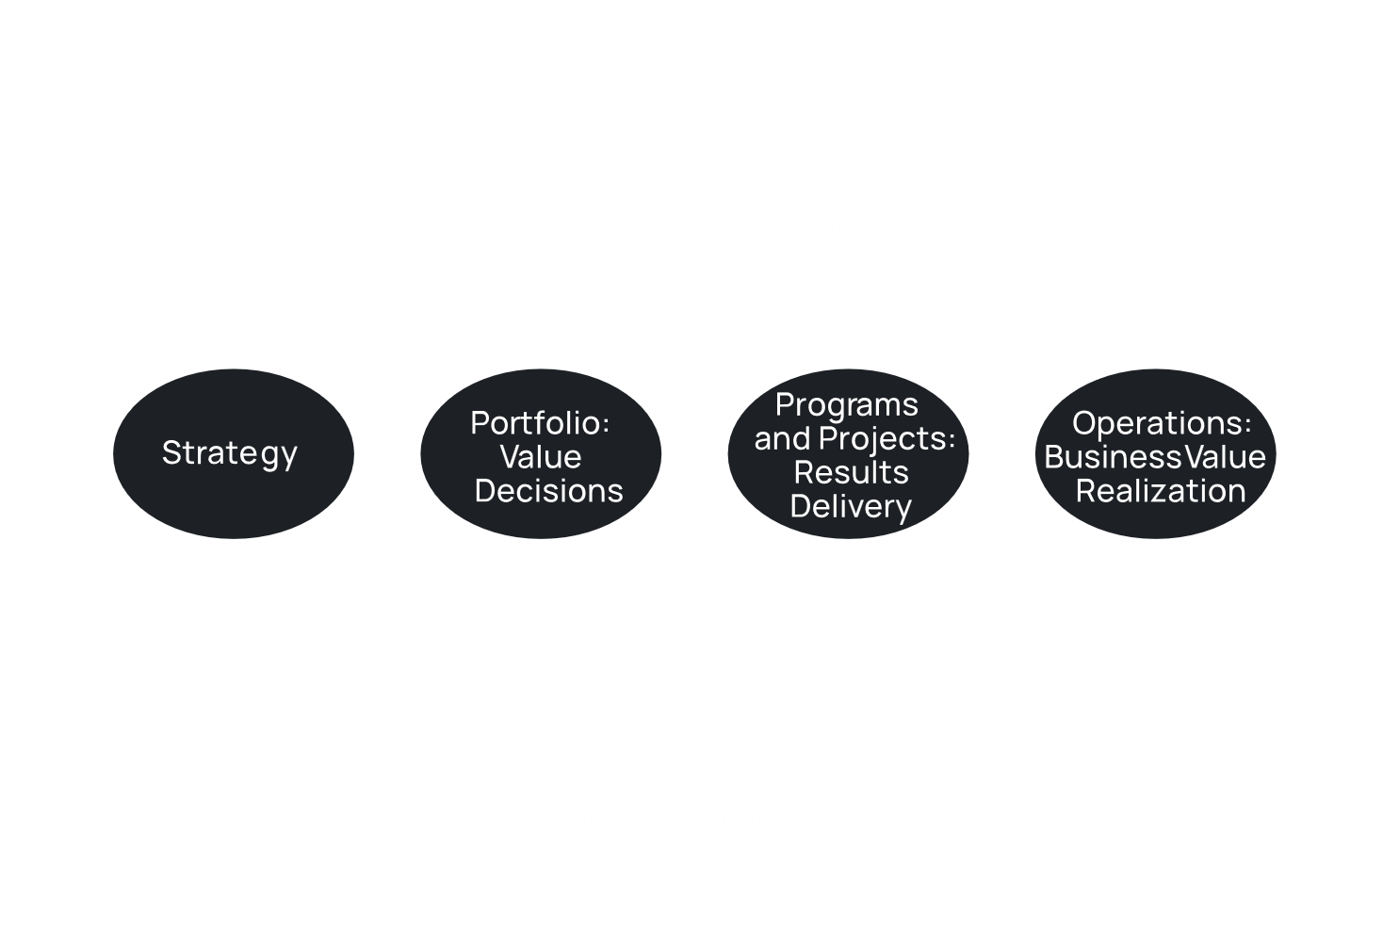

Essentially, based on the organizational strategy, the portfolio manager decides what projects and programs to work with. There is a **business impact analysis** which considers how well the programs and projects are doing and adjusts the portfolio decisions based on it to better align with the business strategy. The operations of each project are handled by the **project manager**. These are overviewed in the form of **value performance analysis** which is a purely black-box analysis. Essentially, if the strategy was to invest 1 million dollars into a business and the value performance analysis shows that we had a loss of 500,000 dollars, we can adjust the organizational strategies to try and make a profit. Of course, this in turn will force the portfolio to change.

## Project Lifecycle Management

There are several models to project lifecycle management:

* **Predictive Model** – Also called the waterfall model, this model takes each step of the project sequentially and does not allow us to go backwards. It is a good model for cases where the end goal is known to not change, such as for a bread making company.
* **Iterative Model** – In this model, we go over all the steps of the project several times, in iterations. In each iteration, we add more features to the end product.
* **Incremental Model** – This model is similar to the iterative model in that there are several iterations, but these iterations are limited to specific steps within the project. The finished product is not available until after the project has ended, unlike in the iterative model.
* **Adaptive Model** – This is the agile model, which uses iterations or increments to allow for the incorporation of changes throughout the development of the project.
* **Hybrid Model** – This is a combination of the predictive and adaptive models. It acknowledges that some parts of the project may be better served using the predictive model while others are better served using the adaptive model.



The actual project life cycle looks like the diagram above. There are four phases, starting the project, organizing and preparing, carrying out the work and ending the project. Each phase is protected by a **phase gate** which essentially checks whether we can pass to the next phase based on several factors.

To manage the project, several processes are used. These processes can be divided into categories called **process groups**. Alternatively, the processes can also be categorized into **knowledge areas**. The process groups and knowledge areas are related to each other in the sense that each knowledge area is useful at different process groups. This relationship is shown in the following table:

|  |  |  |  |  |  |
| --- | --- | --- | --- | --- | --- |
| **Knowledge Areas** | **Project Management Process Groups** | | | | |
| **Initiating Process Group** | **Planning Process Group** | **Executing Process Group** | **Monitoring and Controlling Process Group** | **Closing Process Group** |
| **4. Project Integration Management** | 4.1 Develop Project Charter | 4.2 Develop Project Management Plan | 4.3 Direct and Manage Project Work  4.4 Manage Project Knowledge | 4.5 Monitor and Control Project Work  4.6 Perform Integrated Change Control | 4.7 Close Project or Phase |
| **5. Project Scope Management** |  | 5.1 Plan Scope Management  5.2 Collect Requirements  5.3 Define Scope  5.4 Create WBS |  | 5.5 Validate Scope  5.6 Control Scope |  |
| **6. Project Schedule Management** |  | 6.1 Plan Schedule Management  6.2 Define Activities  6.3 Sequence Activities  6.4 Estimate Activity Durations  6.5 Develop Schedule |  | 6.6 Control Schedule |  |
| **7. Project Cost Management** |  | 7.1 Plan Cost Management  7.2 Estimate Costs  7.3 Determine Budget |  | 7.4 Control Costs |  |
| **8. Project Quality Management** |  | 8.1 Plan Quality Management | 8.2 Manage Quality | 8.3 Control Quality |  |
| **9. Project Resource Management** |  | 9.1 Plan Resource Management  9.2 Estimate Activity Resources | 9.3 Acquire Resources  9.4 Develop Team  9.5 Manage Team | 9.6 Control Resources |  |
| **10. Project Communications Management** |  | 10.1 Plan Communications Management | 10.2 Manage Communications | 10.3 Monitor Communications |  |
| **11. Project Risk Management** |  | 11.1 Plan Risk Management  11.2 Identify Risks  11.3 Perform Qualitative Risk Analysis  11.4 Perform Quantitative Risk Analysis  11.5 Plan Risk Responses | 11.6 Implement Risk Responses | 11.7 Monitor Risks |  |
| **12. Project Procurement Management** |  | 12.1 Plan Procurement Management | 12.2 Conduct Procurements | 12.3 Control Procurements |  |
| **13. Project Stakeholder Management** | 13.1 Identify Stakeholders | 13.2 Plan Stakeholder Engagement | 13.3 Manage Stakeholder Engagement | 13.4 Monitor Stakeholder Engagement |  |

## Project Management Business Documents

There are two types of business documents that are related to project management, business cases and benefits managements plans. Both of these documents are prepared before the project lifecycle begins, since they are used to determine whether or not a project should be initiated.

### Business Cases

A **business case** is an **economic feasibility study** used to determine the validity of the benefits of specific components of a project. It documents:

1. Business Needs – This part determines why the components are needed including the identification of the scope of the component and the stakeholders affected by it.
2. Analysis of the Situation – This includes identification of the root causes of the problem, risk analysis, critical success factors, etc. Each criterion here can be placed on one of three categories:
   1. Required – The criterion must be met in order to solve the problem.
   2. Desired – The criterion is desirable but not absolutely essential.
   3. Optional – Non essential.
3. Recommendations – Based on the above, a recommended course of action is provided.
4. Evaluation – A method to measure the benefits obtained by the plan is provided.

### Benefit Management Plan

The **benefit management plan** documents how and when the benefits of the project will be delivered. It documents:

* The target benefits, i.e., the tangible and intangible gains from the project
* The benefits owner, which is someone who will be held accountable for ensuring the benefits are obtained
* A measurement of the success of the project. This can be done using various financial measures such as:
  + Net Present Value (NPV)
  + Return on Investment (ROI)
  + Internal Rate of Return (IRR)
  + Payback Period (PBP)
  + Benefit-Cost Ratio (BCR)